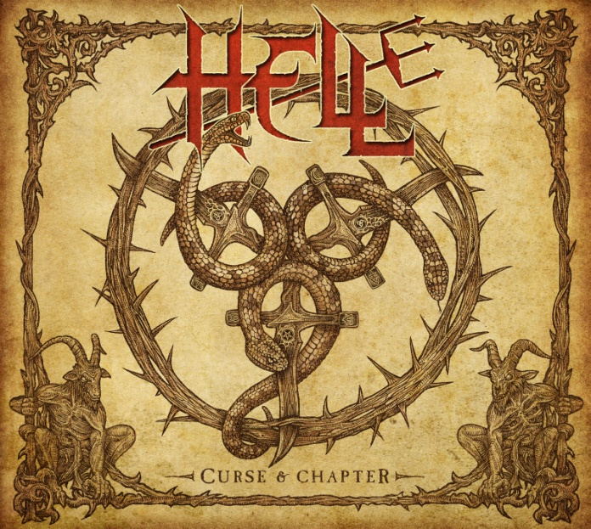

**HELL**

»Curse And Chapter«

##### OUT: November 22, 2013

|  |  |
| --- | --- |
| **Line up:** | **HELL online:** |
| David Bower | Vocals  Kev Bower | Guitar, Keyboards, Vocals  Andy Sneap | Guitar  Tony Speakman | Bass  Tim Bowler | Drums | www.facebook.com/hellofficial  www.hell-metal-band.com www.nuclearblast.de/hell |

Risen from their own legacy, having disbanded in 1987, **HELL** were reincarnated  in 2011 with the addition of **Andy Sneap** (guitar) and **David Bower** (vocals) joining original members **Kev Bower** (guitar and keys), **Tony Speakman** (bass) and **Tim Bowler** (drums). Now the British quintet is about the release the follow-up to its highly acclaimed debut **»Human Remains«** (Nuclear Blast 2011) which reached a respectable #46 of the German album charts. Since the release, the band have toured relentlessly, playing numerous major festivals including world famous events such as Tuska, Rock Hard, Bang Your Head, Metalfest, PPM, Alcatraz, Rockstad Falun, Sweden Rock, Summer Breeze, Metalcamp, Masters Of Rock, Download, and many others - as well as the legendary Bloodstock Open Air, which was broadcast as a live stream on Dailymotion, and for which the band have TWICE been named as 'Best Mainstage Performance'.

The band's first album received many awards and accolades, including '2011 Album Of The Year' in Sweden Rock magazine, '2011 UK Album Of The Year' in Metal Hammer, and finishing in the top 5 of many other respected magazines including Aardschok and Rock Hard. The band were also nominated for a UK 'Golden Gods' award.

In 2012 **HELL** joined forces with legendary German metal act **ACCEPT** on their 'Stalingrad' European Tour, completing a touring schedule which saw the band play shows in 16 different countries. In November 2013 **HELL** will again complete another extensive European/UK/Scandinavian tour as guests of **AMON AMARTH** and **CARCASS.**

The sophomore offering of the band, **»Curse And Chapter«**will also be released via Nuclear Blast on November 22nd 2013. It will include a bonus DVD, offering six songs from their show at the »Darwin Suite Assembly Rooms« in Derby, on February 23rd, 2013 plus additional material recorded at Bloodstock Open Air.

As a first lead-off single, **HELL** will release a 4-track EP including the opening track of the forthcoming record, entitled **‘The Age Of Nefarious’**.

Commented **Sneap** – who also produced the record - on the upcoming release: *"This time around the album consists of around 50% old material 50% new. We really see this as a band that’s moving forward rather than a nostalgia trip, obviously there's a lot of history within the band, but there's also a whole world of ideas we want to get out. I'm super happy with how things are shaping up, it feels more like a band on this record to me than the first, which I guess is just a natural progression of everyone playing together a lot more over the last couple of years."*

Concerning the lyrical content, vocalist **David Bower**added: “*Alongside some of our favorite themes of historical, political and religious persecution, intolerance and prejudice, you will find some good old fashioned myths and legends being invoked and reinterpreted in our own inimitable way. We also have some songs in which the listener will be implicitly invited to solve the clues contained in the lyrics in order to find the meaning of the stories for themselves. Being completely aware that many people interpret things in ways that writers do not expect as a matter of course, it seemed logical to take that idea a little further. “*

About the album title **Bower** explains: *“It's a hellish play on words of the English saying 'Chapter And Verse', and it's also a reference to a song lyric in ‘The Age Of Nefarious’, the opening track on the record.”*

© Nuclear Blast